
Lesson 7 Teacher's Key: On the Move
001 Game Creator (Windows only) - Instructor Reference Only
VIDEO GAME CREATION

What This Lesson Teaches
The 001 Game Creator equivalent of the GameMaker bugfix: the 'Defeated / Destroyed' Actor Trigger fires on ANY destruction of an Actor instance, so it cannot be trusted for win-counting once a second destruction pathway (the new 'Left/Entered Camera' escape-cleanup trigger) exists.

The Bug Being Fixed
This is the second primary bugfix engine for this lesson, alongside GameMaker. Lesson 6 wired the enemies_remaining decrement and win Message Box into the enemy Actor Template's 'Defeated / Destroyed' trigger. That trigger fires on any destruction of the Actor, regardless of cause - including the new 'Left/Entered Camera' escape-cleanup trigger this lesson adds. Left unfixed, an enemy escaping off the bottom unshot would still decrement enemies_remaining and could trigger a false 'You Win!' message. The fix: delete the 'Defeated / Destroyed' trigger entirely, and move the decrement plus win check into the existing 'Collided with actor' trigger instead - the one trigger that actually represents a hit.

Level 1 - Full Worked Solution
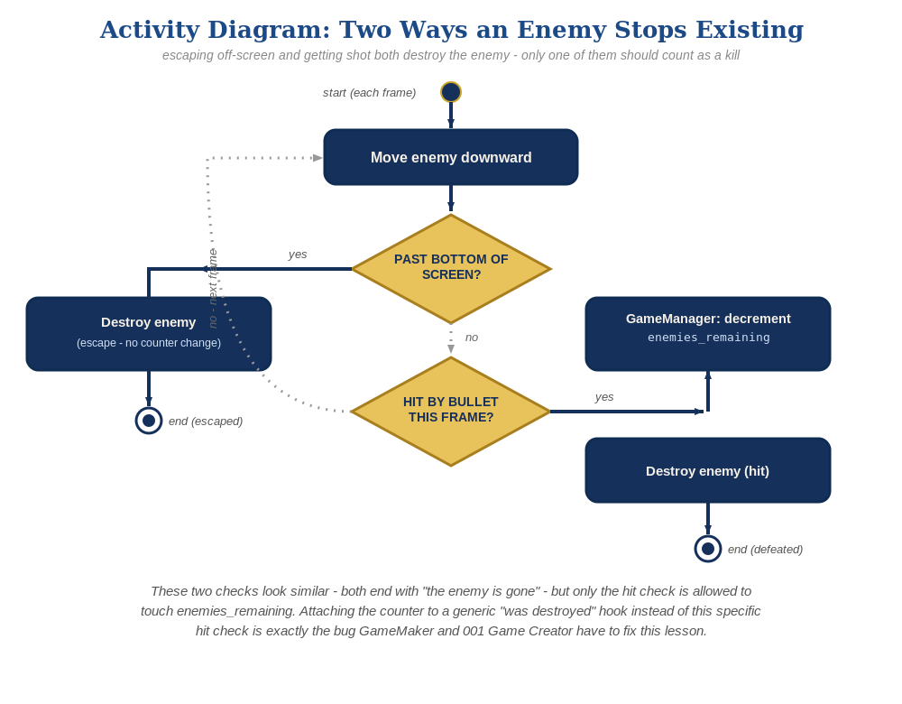
The general escape-vs-hit distinction behind this week's exercise - the same shape in every engine, whatever the exact code or blocks look like.
- The enemy Actor Template's Automatic Movement setting (Move = true, Direction = Down) reuses the exact mechanism already taught for the bullet's upward movement in Lesson 3 - no new concept, just a new direction and a slower speed.
- The new 'Left/Entered Camera' (Left case) trigger reuses the exact mechanism already taught for the bullet's off-screen cleanup in Lesson 3 - a plain Destroy, no awareness of enemies_remaining.
- The existing 'Collided with actor' trigger is now the single source of truth for enemies_remaining, with the decrement and win-check Events added alongside the existing Destroy Events already there from Lesson 4/6.
- The old 'Defeated / Destroyed' trigger is deleted entirely from the enemy Actor Template - it has no job left to do.
enemy Actor Template settings:
Automatic Movement -> Move = true, Direction = Down
enemy Actor Trigger: Left/Entered Camera (Left case) ->
Actor - Destroy/Revive Actor(this, Destroy)
enemy Actor Trigger: Collided with actor (revised) ->
Variable - Modify Value(enemies_remaining, Subtract, 1)
If(enemies_remaining <= 0)
Message Box("You Win!")
Actor - Destroy/Revive Actor(relate, Destroy)
Actor - Destroy/Revive Actor(this, Destroy)
enemy Actor Trigger: Defeated / Destroyed -> deleted entirely

Why This Structure
- 'Defeated / Destroyed' is 001 Game Creator's equivalent of a generic lifecycle hook - it fires whenever the Actor instance stops existing, for any reason, exactly like GameMaker's Destroy event. Both engines share this exact pitfall because both offer a convenient 'on destroyed' hook that's tempting to use for win-counting, and both need the identical fix: move the logic to the specific trigger that represents the actual game event.
- 'Collided with actor' fires on overlap with any Solid Actor, not just the bullet specifically - but the bullet is the only other Solid Actor moving toward the enemy at this point in the semester, so in practice it's still a much stronger signal for 'a kill happened' than 'this Actor stopped existing.'
- Reusing the bullet's exact Lesson 3 patterns (Automatic Movement, Left/Entered Camera cleanup) for the enemy this lesson is a deliberate continuity choice - students who understood those mechanisms for the bullet don't need to learn anything new to apply them to the enemy, just recognize the same tool solving a similar problem.
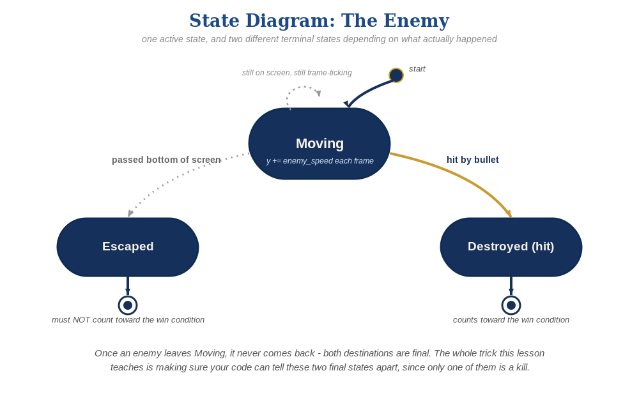
The enemy's two possible endings this week - only one of them should count as a kill.

Level 2 / Level 3 Talking Points
- Same as GameMaker: spend extra time here, since this is a genuine latent bug from Lesson 6, not something students did wrong at the time.
- Ask students to predict what happens if they add the new logic to 'Collided with actor' but forget to delete 'Defeated / Destroyed' - answer: double-counting, since a shot enemy triggers both triggers (the collision AND its own consequent destruction), decrementing enemies_remaining twice per actual kill.
- If a student asks why the enemy needs a NEW trigger for escape cleanup instead of just reusing 'Defeated / Destroyed' for that too - explain that's exactly backwards: the problem is that a single generic trigger tries to mean two different things at once. Two specific triggers (Collided with actor for kills, Left/Entered Camera for escapes) is the fix, not a workaround.

Common Student Mistakes
- Leaving 'Defeated / Destroyed' in place AND adding the new logic to 'Collided with actor' - causes double-counting exactly like the GameMaker equivalent. Test for this explicitly: shoot exactly half the enemies and confirm the win message does NOT appear early.
- Setting 'Left/Entered Camera' to the 'Entered' case instead of 'Left' - fires immediately when the enemy spawns into view instead of when it exits at the bottom.
- Forgetting to set Direction to Down on Automatic Movement (leaves it at whatever default/previous direction was set, if the Template was copied from another Actor).

